🍽️ Recipe Ideas App

A simple and elegant React.js web application that allows users to submit their favorite recipe ideas. This app is designed to collect basic recipe details like name, ingredients, and cooking instructions.

## 🚀 Live Demo

Open app

Stackblitz app in google chrome

<https://stackblitz.com/edit/vitejs-vite-fmfkhzu2?file=src%2FApp.jsx>

## 📸 Preview

Screen shots

Start

Open (only browers )

For example

Chicken

Rice

Water

We can see my project different types of food can order

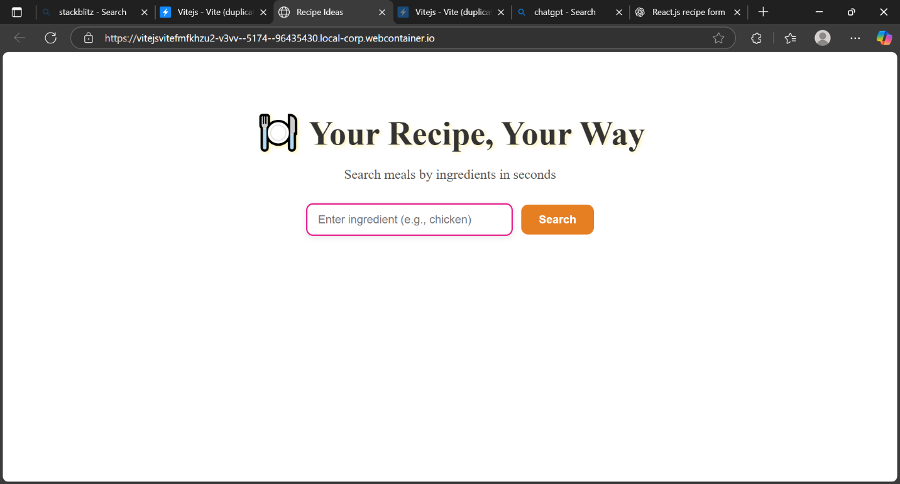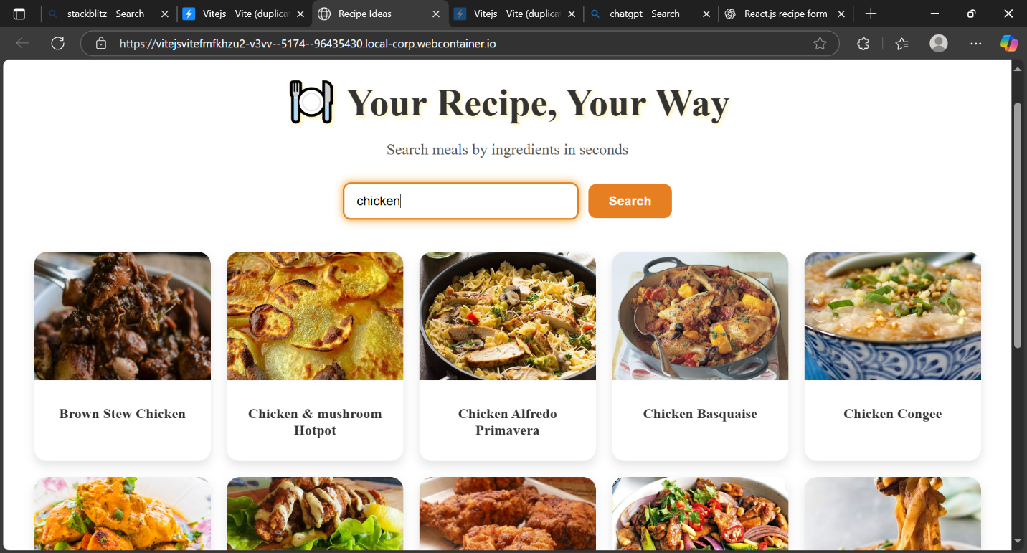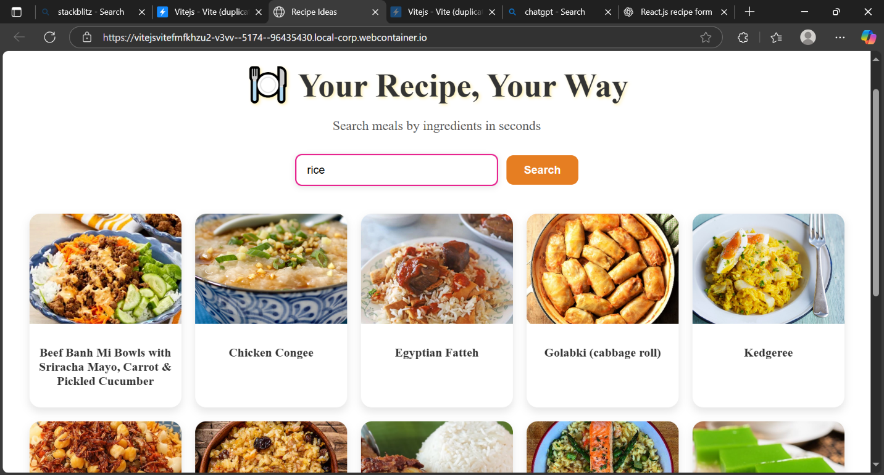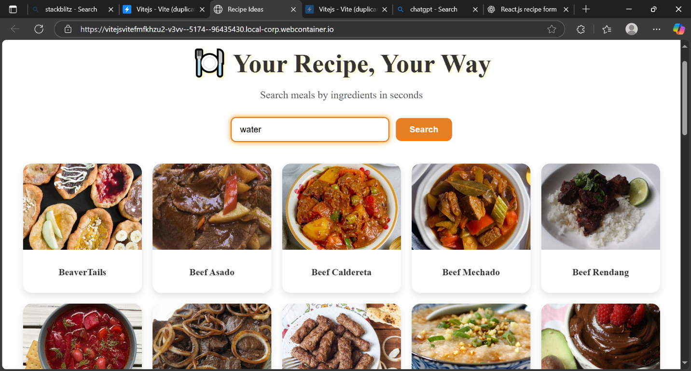

---

## 🔧 Features

- 📥 Recipe Name, Ingredients, and Instructions form

- ✅ Simple input validation

- 💾 Submit feedback message

- ⚛️ Built using React functional components and hooks

---

## 🛠️ Tech Stack

- **Frontend**: React.js, JSX, CSS

- **State Management**: useState (React Hooks)

- **Styling**: Inline CSS (can be replaced with CSS Modules or Tailwind)

- **Deployment**: Netlify / Vercel

recipe-ideas-form/  
├── public/  
│ └── index.html  
├── src/  
│ ├── App.js  
│ ├── RecipeForm.js  
│ └── index.js  
├── package.json  
└── README.md

**Install dependencies**

npm install

npm start

**Future Improvements**

* Save recipes to local storage or a database
* Fetch suggestions from TheMealDB API
* Add user login and favorites list
* Improve form validation and UI styling

Chatgpt link

https://chatgpt.com/share/68c00fa0-73e0-8003-b548-070dc894a1c6